Snap! The shark as model photographist
a talk at MOTE 102, Edinburgh, 22nd Nov 2023
Melissa McCarthy
mccmccj@gmail.com

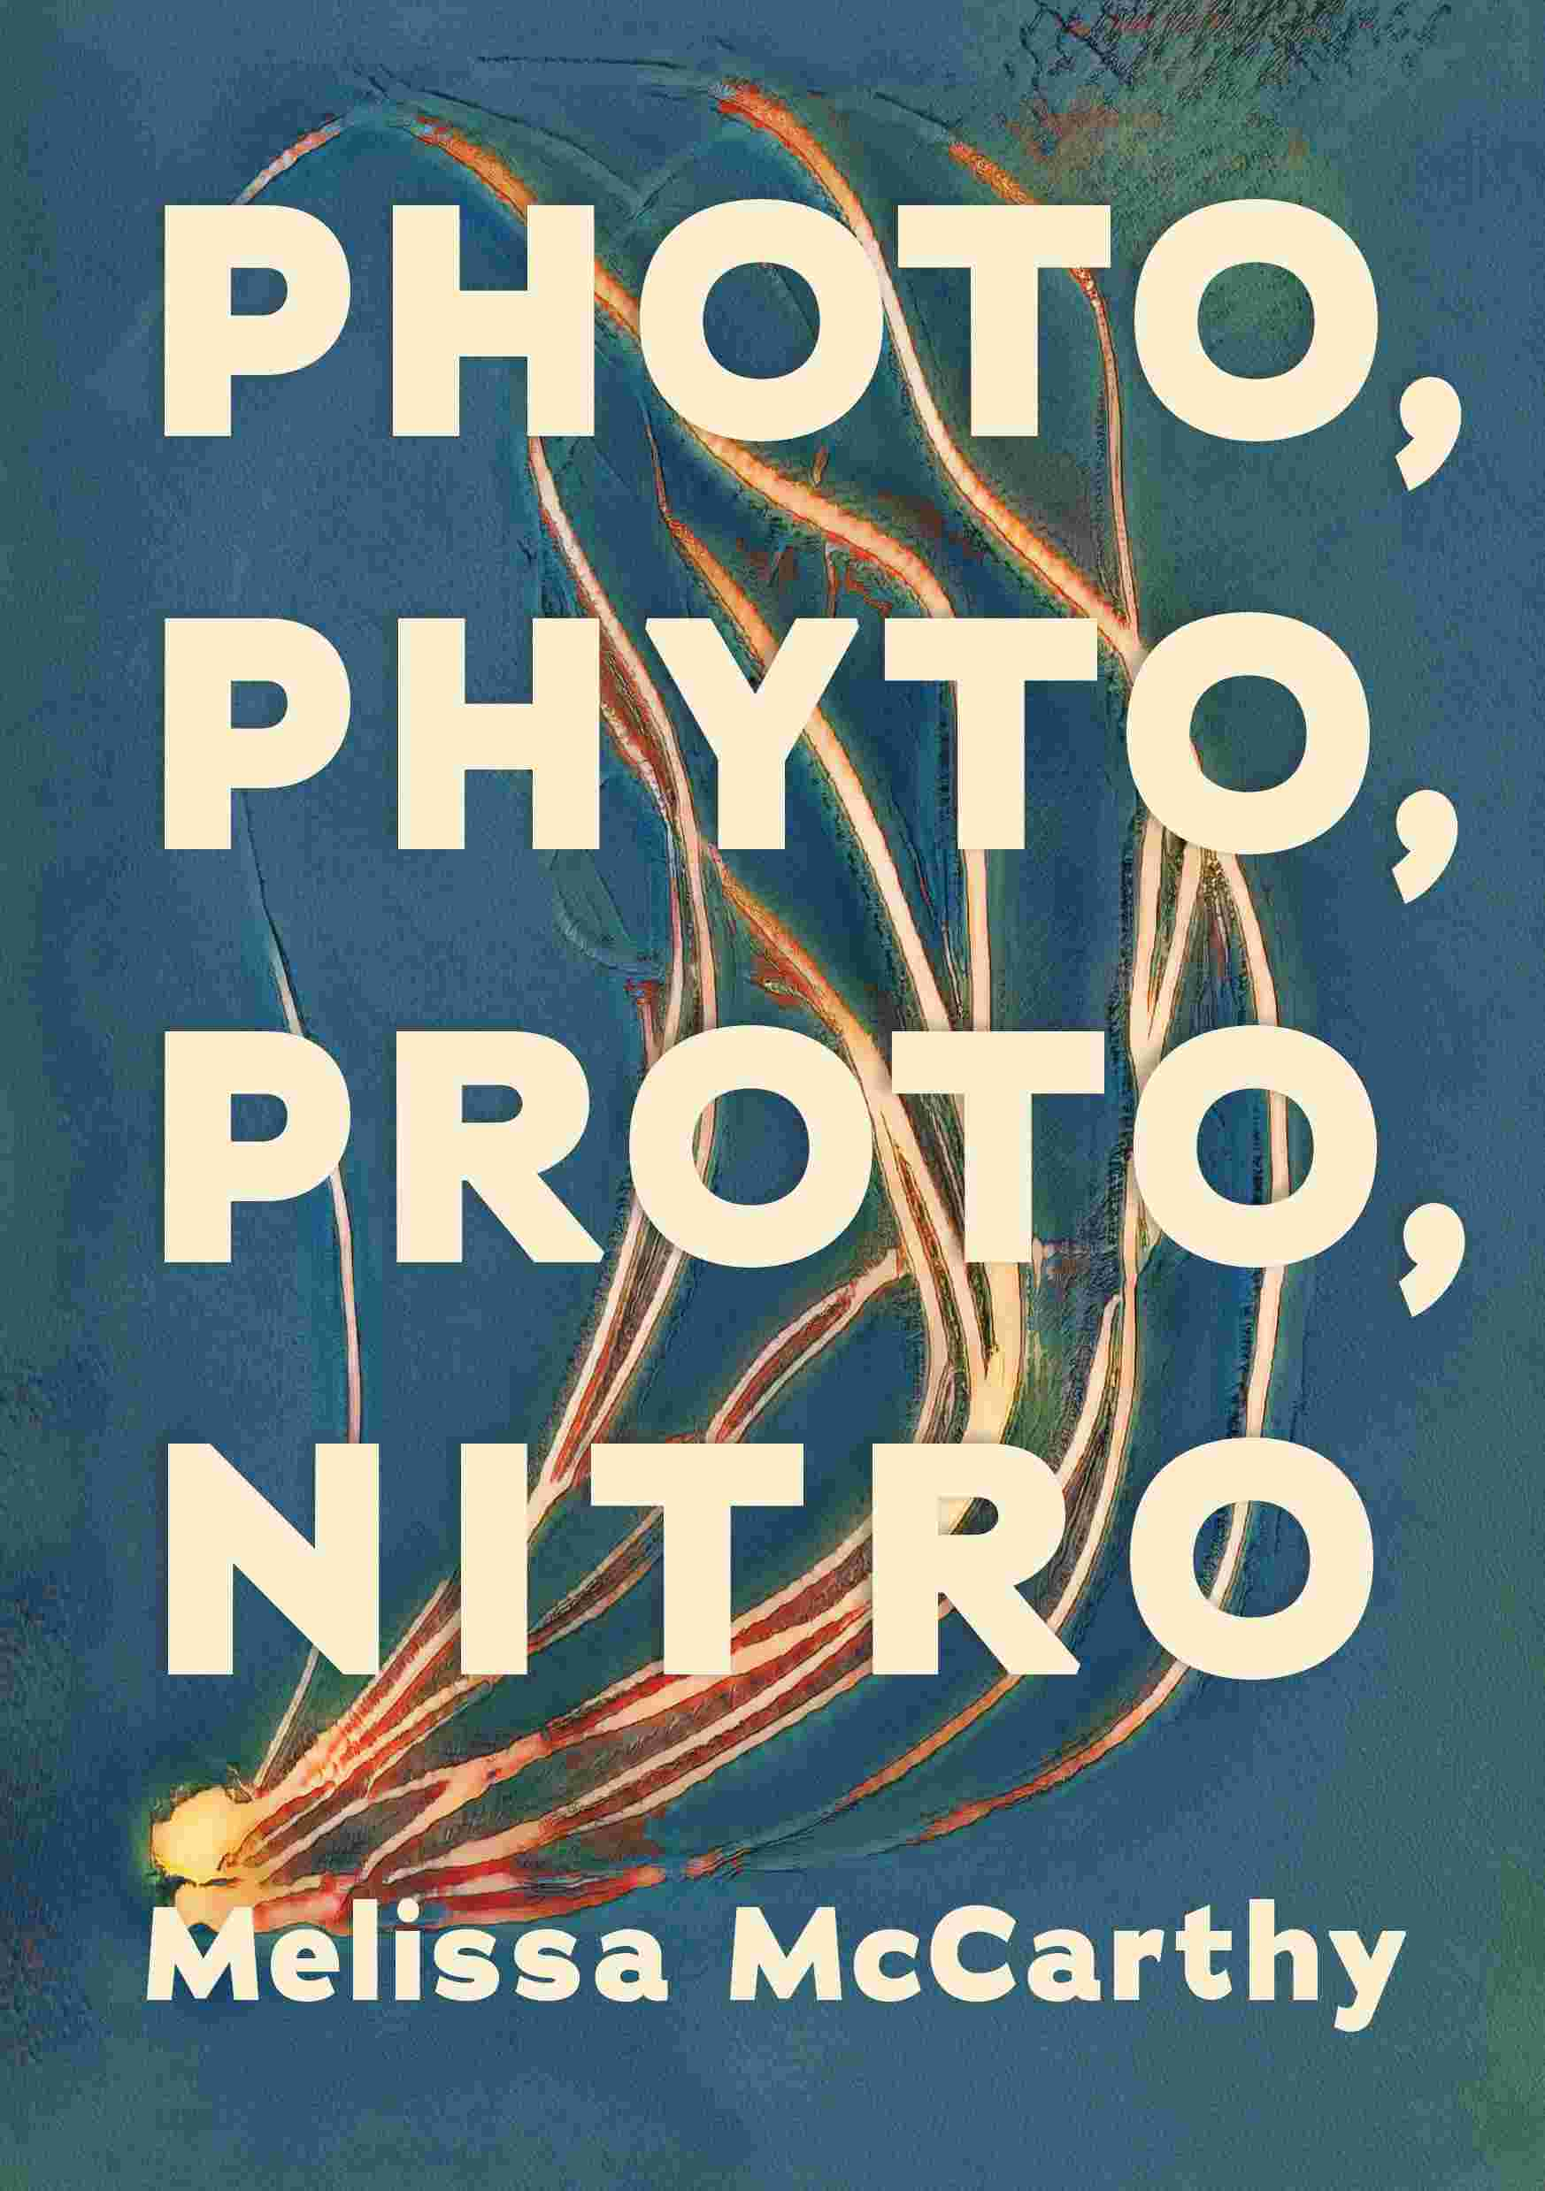
Hello, thanks Tom, thanks Alice Bain here at MOTE, thanks bartenders, and thank you for coming this evening.

What I want to talk about here is:
the idea of the shark as photographist. Not quite photographer; that would be ridiculous. But photo – graphist –
One who is involved in the making of marks by means of light. Something like that.

And I’ll do this in order to answer a question that everyone asks, which is, what’s your new book all about. People ask that, and they correctly say that it’s a great title. So I’ll explain that, too. The title consists of four words that are used as prefixes; they are mixed together with other component parts, or, words, to cast a different light on what the whole thing means.

And these four words are:
Photo – to do with the action of light. Photography, of course, or, photosynthesis, using light as your form of energy in order to grow.
Then, phyto is from the ancient Greek word for plant; it means, in botany now, relating to a thing which grows.
Proto, means, the first: like a prototype, the first iteration of a design,
And,
Nitro, connected to the element nitrogen. Such as, nitroglycerine, an explosive. Or, nitrate film, which was used in cinemas in the early twentieth century but which tended to cause catastrophic fires.

So that’s the title. What’s the book about?
Photography, I tend to say, and I do describe and trace some of the inventions that contributed to the development of this process, or activity, or art form, from its explosive growth in around 1839 onwards.
Or, sometimes I explain that it’s a high-brow – but not boring – essay in which I discuss flowers, photographs, explosions, sharks. People like this description. From Hiroshima and the birth of the nuclear bomb, through architecture and ruins, back through Jaws, the book and the film, right the way back to Greek tragedy and the fall of Troy. In all these fields (and battlefields), I notice some similar tropes recurring: particularly, flowers keep appearing in the ruin and the rubble, along with wooden boxes. And I investigate why, and what this might tell us about art. Or, what it might tell us about memory, repression, trauma. Same deal.

Or, as Tom pointed out in his very perceptive blurb, you could say that this is a book about metaphor; about using language to identify similarities and point out comparison. I’m really keen on metaphor, as a way of saying that this is like that, not in all ways but in some important aspects.
For example, here’s a metaphor: “The great conical head struck her like a locomotive, knocking her up out of the water.” It’s a quotation from this book, Jaws.

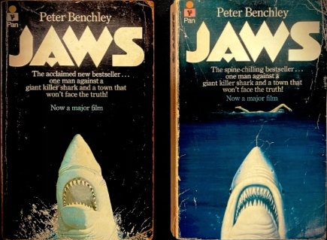

specifically, it’s a simile, which is a type of metaphor, asserting that a shark’s head is like a locomotive, a train, a sort of vehicle. Or, from the same opening pages, the simile that the blood streaming from the bitten woman’s femoral artery is “a beacon as clear and true as a lighthouse on a cloudless night.” in the way that it notifies and attracts the shark. The author, Peter Benchley, is comparing a stream of blood to a beam of light. This is like that.

Metaphor: two separate things are similar, in a way that amplifies and enriches my understanding of both halfs of the comparison. Sometimes it’s just funny, to realise that this thing is like that thing. Sometimes it gives you a clearer understanding of , or a new insight into, the elements under consideration. But more than just the two terms, when metaphor is really working it’s not the particular points that matter, it’s the broader idea, the realisation that everywhere we look there are points of overlap. Nothing is unrelated, uncomparable, to something else. It just depends on adjusting your perspective, framing, depth of vision, a bit. Then you get a better picture of the whole world.

But all this is a bit vague, out of focus. It might explain better if I look at three specific images carefully, talking through what I can see, or what I think I can see, then maybe looking a bit further, under the surface. So, shark pictures.
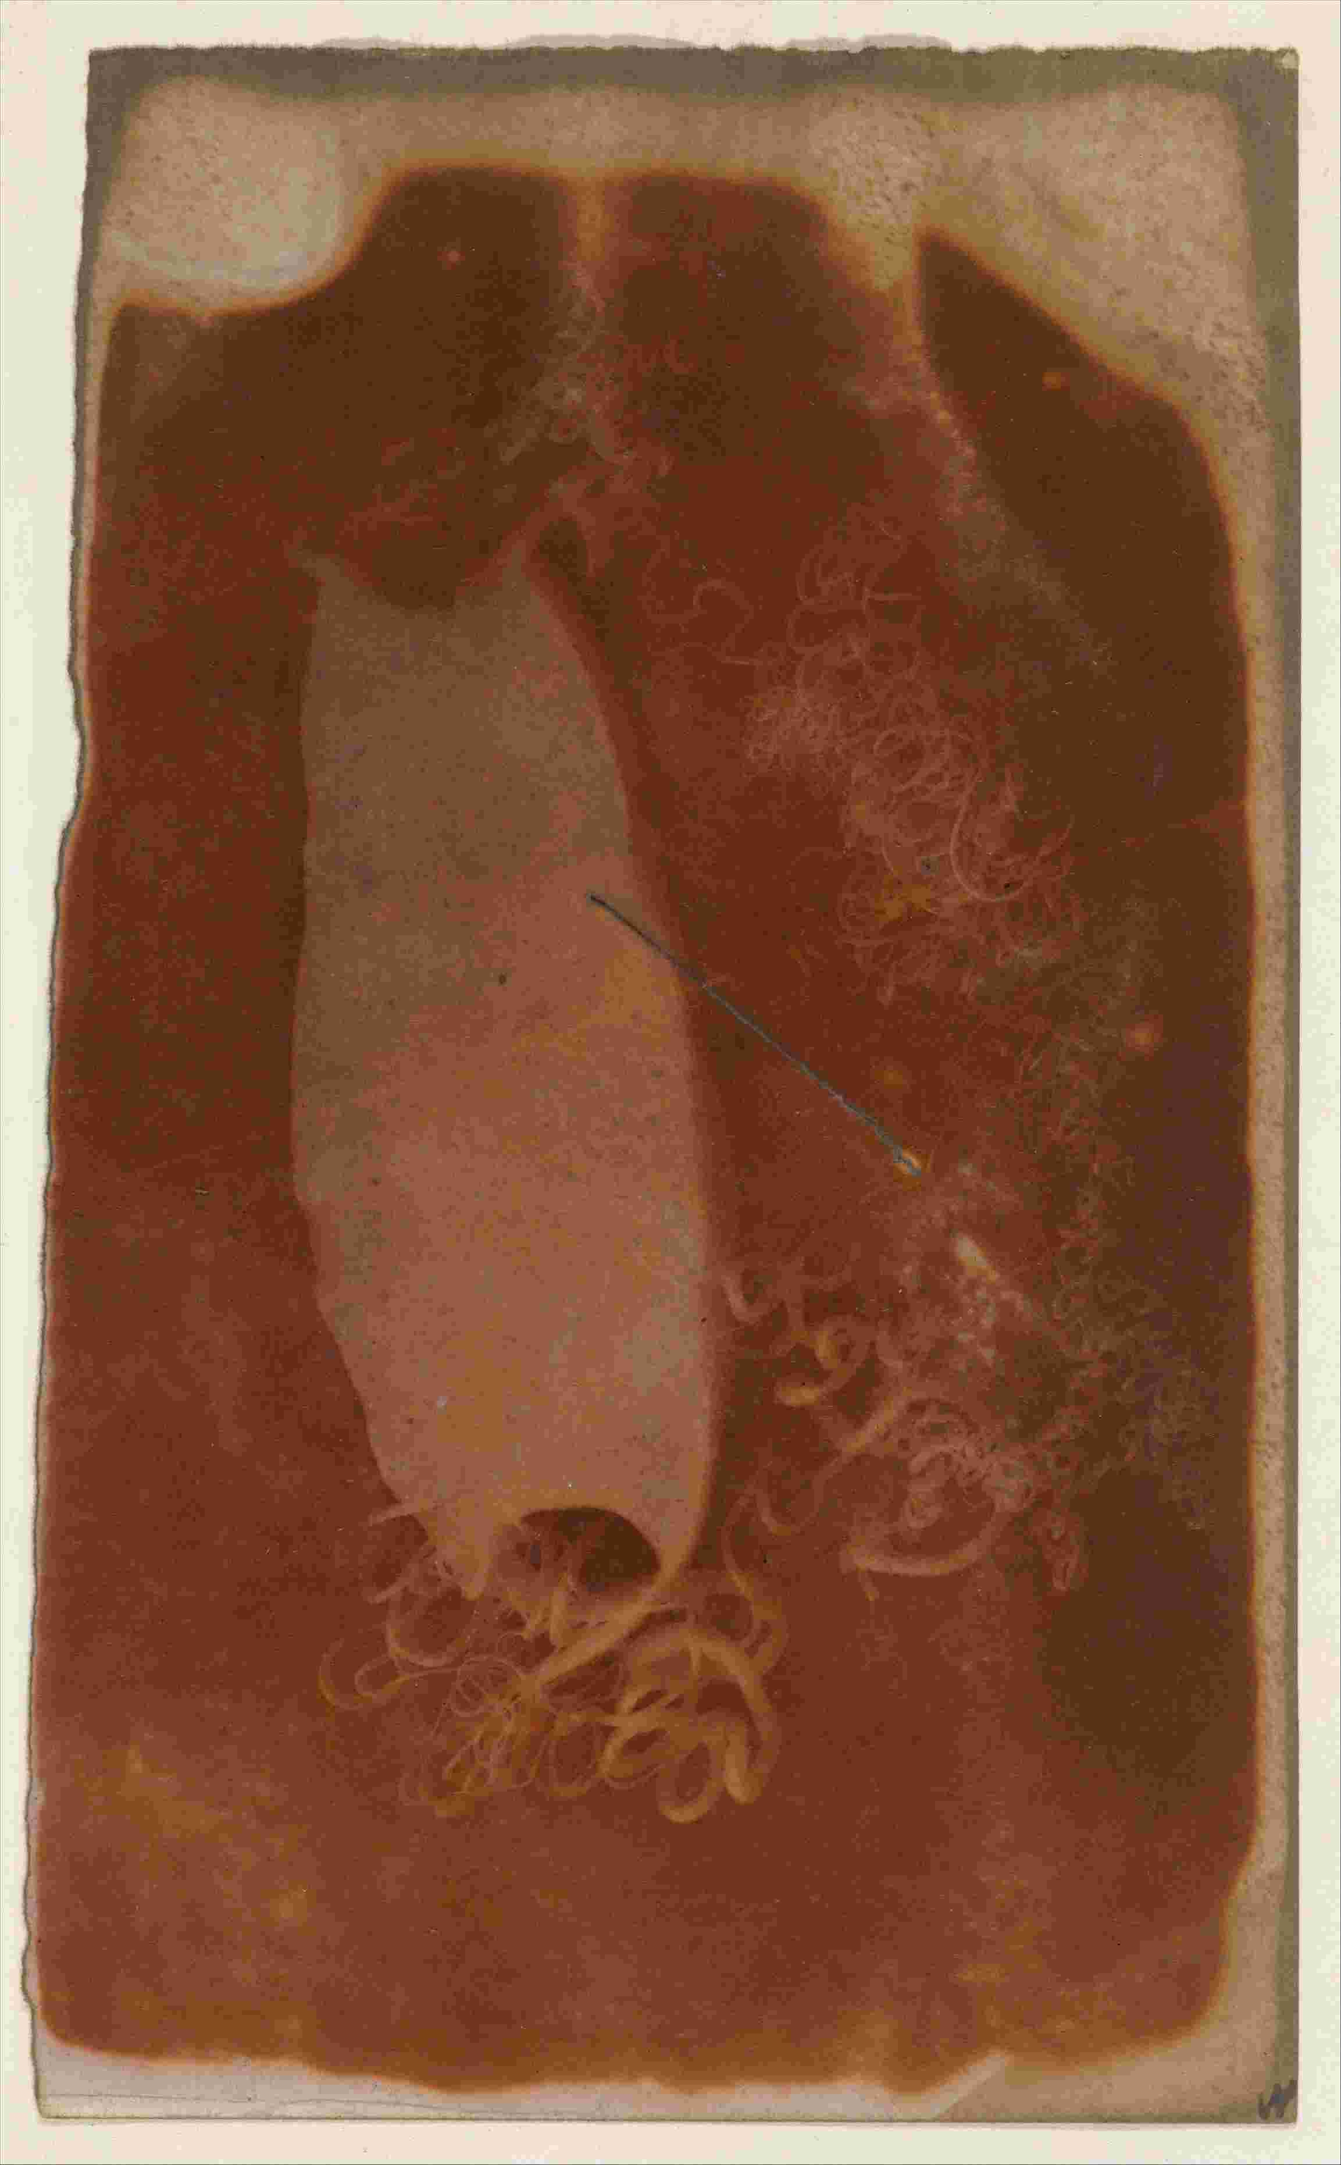

First one here, is from New York’s Metropolitan Museum of Art, a picture of a Scylorhinidae (or catshark) shark egg case. The colloquial name for this object or remnant is, mermaid’s purse, because, this looks like that. The picture, and the egg case, were made around 1840 – 45. The form of this object is that it’s a salted paper negative print, which means that it’s a negative – light and darkness reversed – made by placing the item – the egg case – on the prepared photographic paper and exposing them to light until an image appears. It’s the sort of image called a photogram.

This artwork then is very early. It was only perhaps a year before this, in 1839, that the French pioneer Daguerre unveiled his first photographic image. Through the 1830s Fox Talbot and others in the UK were experimenting; here in Edinburgh in the 1840s it was home to the image-makers, Hill and Adamson, most famously. All of these were investigating different techniques and materials. Daguerre, for example, used a metal surface for his shiny daguerreotypes. The Scottish and the English pioneers, in contrast, tended to make work on paper: calotypes and photograms like this one. With the fibre of the paper showing through, a calotype isn’t shiny and reflective, but has this nice soft and textured surface, paper like skin.

All the processes, though, used the same building blocks of image creation, and it works like this:

to make a photo you need a receptive surface, one that’s been treated with chemicals that are photosensitive: they react to light. You keep this surface, or plate, or paper, in the dark until it’s needed. Then you expose it to light, but not all of the paper is hit by the same amount; some light is blocked out either by putting a physical object in the way, or by controlling the influx of light by use of a lens. On the paper that is struck, the chemicals change their structure so that they look different. You can fix these altered areas, and prevent the other parts from changing later. Then you have retained the image. You have it, you’ve taken the photo.

That’s the underlying process in all analogue, chemical photography, including here, for this shark photogram. As for the subject, it’s shark pregnancy. As you might guess, shark sex and reproduction are extraordinary. I won’t even go into this now.
But, re. pregnancy as it’s depicted here: some sharks carry their embryos within the body. In this case the not-yet-born sharks occasionally eat each other, in a bout of intra-uterine cannibalism, which is disgusting. Then the mother gives birth to the remaining, live shark.
Some lay eggs in the ocean, which later hatch. Some sharks do a combo of these two, with the embryo inside the egg inside the body.
This, from the catshark family, is an example of the oviparous type of birth, where the baby shark leaves the mothership, goes out in its capsule and waits for a while before it’s ready to launch into the rest of the medium (the water).

When it does so, it leaves behind the mermaid’s purse that has been the container for the new life. It reminds me of

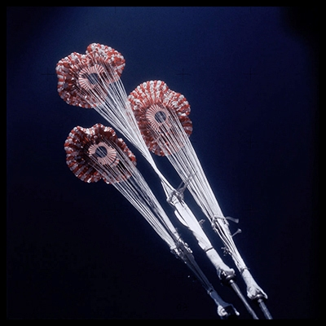

a launch capsule from one of the early space missions, some sort of booster bit of the rocket that falls away after its task is done. Or it might be left on the moon, now that the inhabitants don’t need it any more. Or maybe the opposite, it’s like the command module that’s the only part left by the end of the mission, the bit that the astronauts stay in and it comes back to earth, falls back into the ocean, then floats around – like this one, from NASA’s Skylab, 1973; here the module is falling to earth then

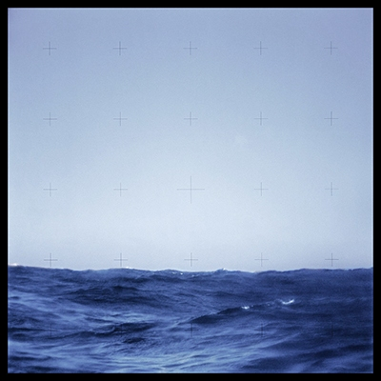

the view from inside as it floats. Then it washes up on the beach, this rocket does. In the same way as a mermaid’s purse;

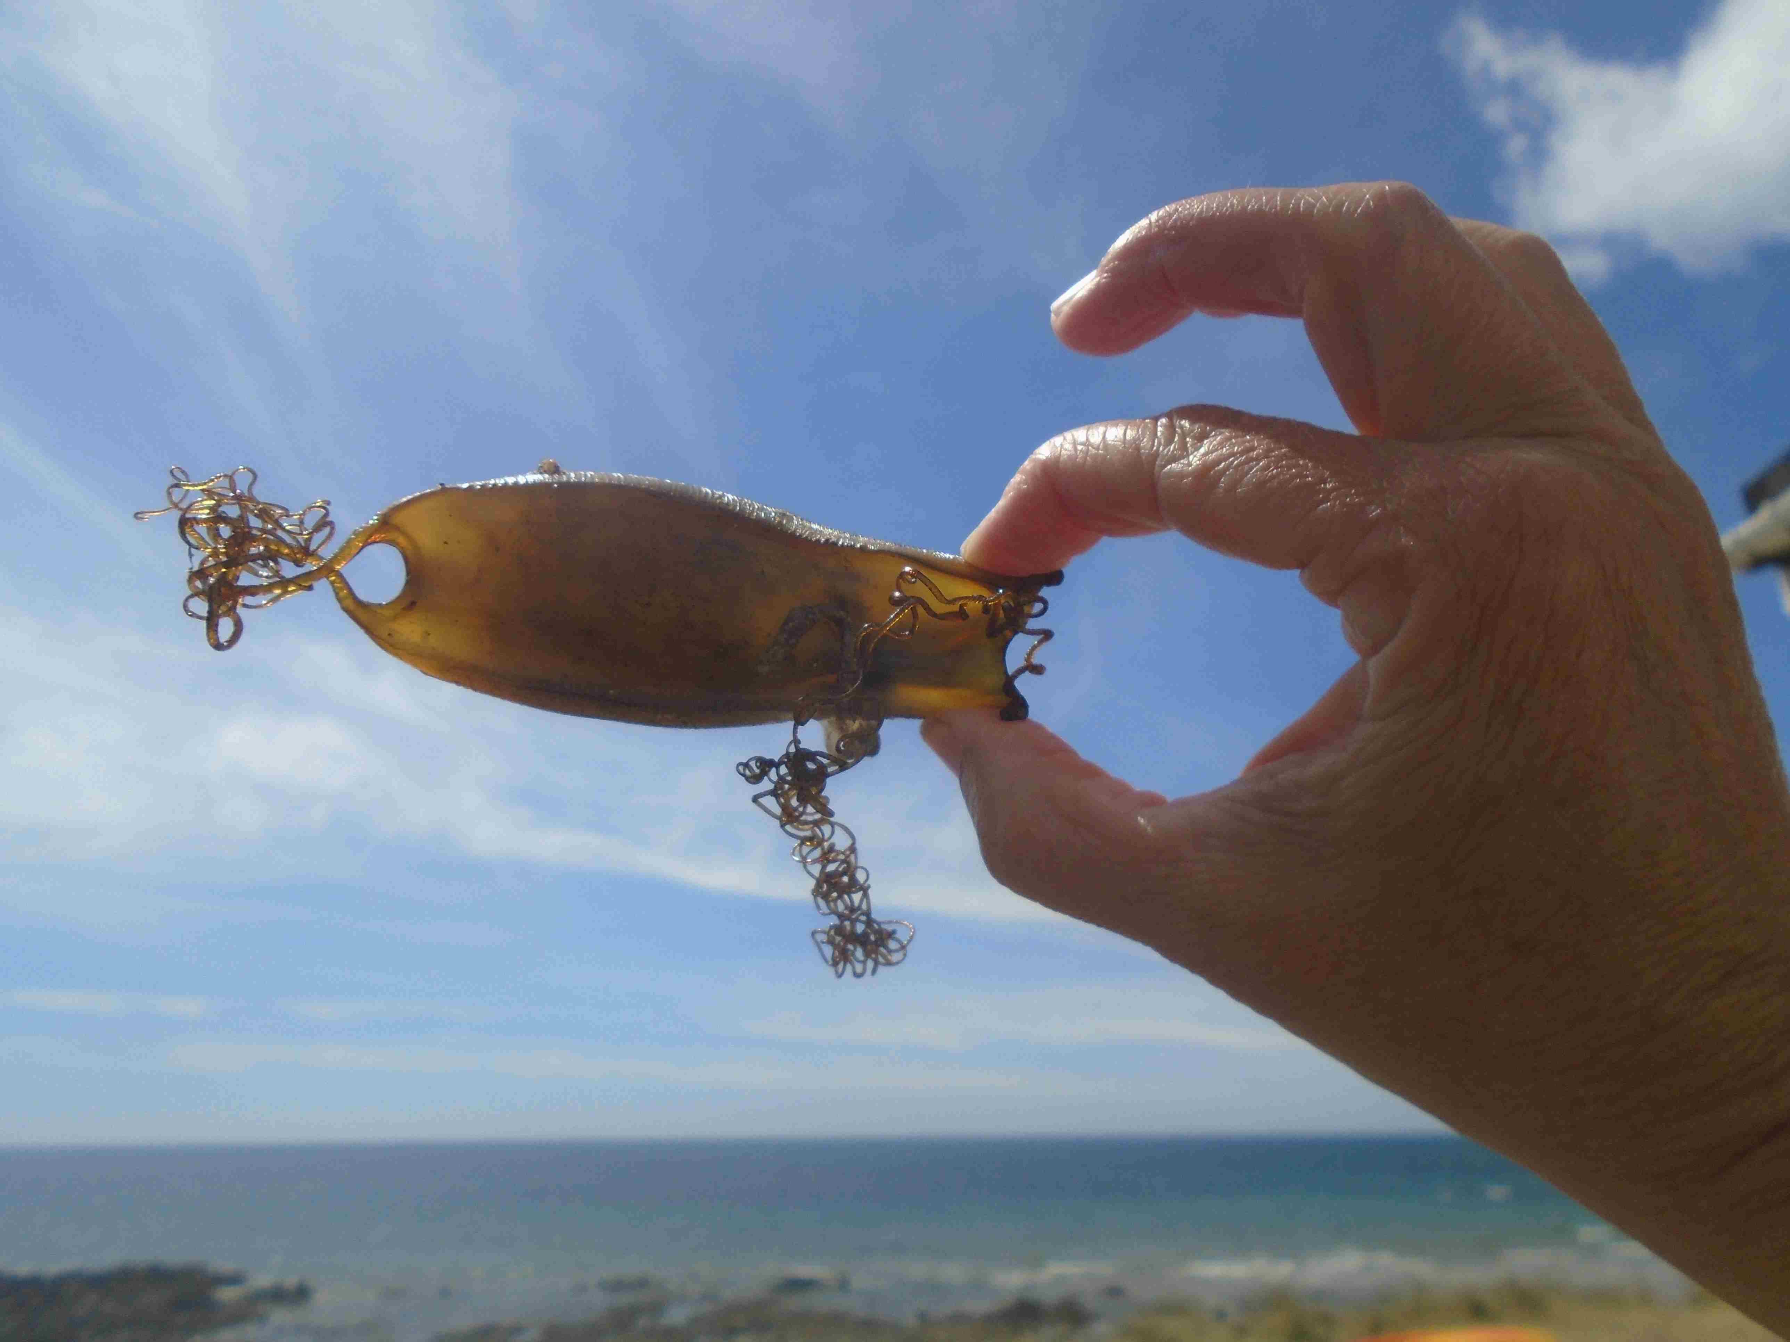

here’s one that Jess is holding in this pic from last year.

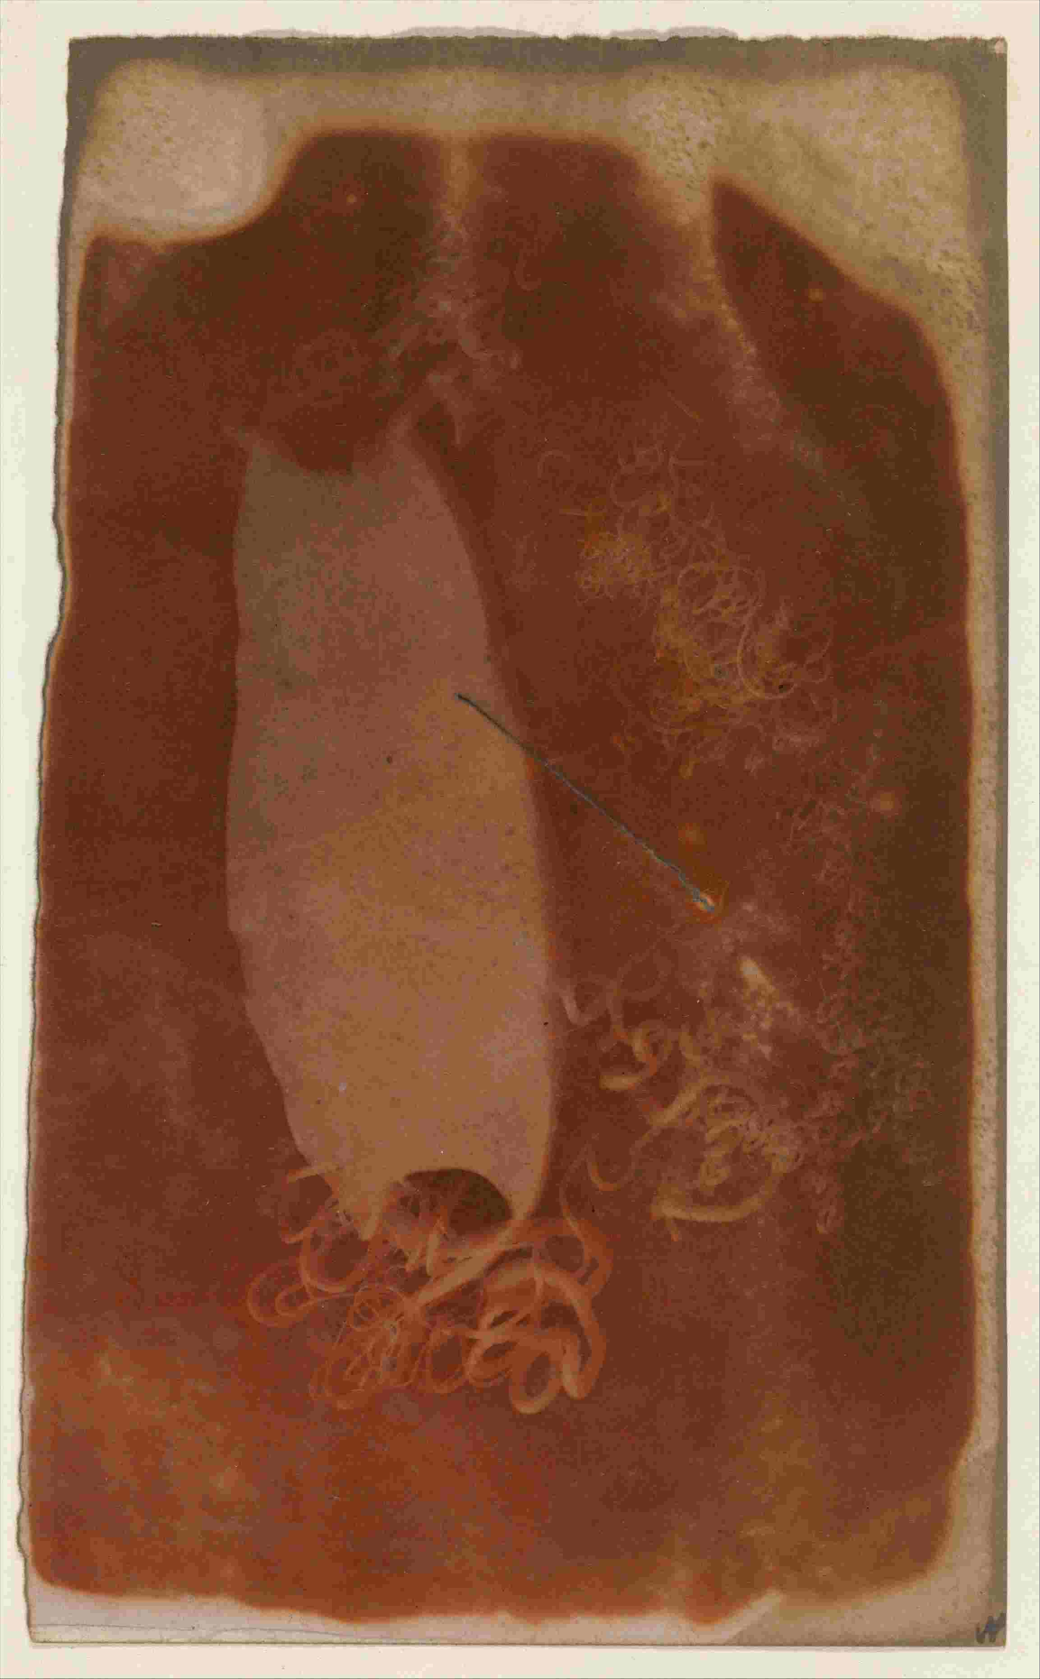
But here, here in the old salted paper negative, what the photographer (of uncertain identity – it might be one Sarah Bright) – what she does in the early 1840s is: find this case washed up on the shoreline. She picks it up, lets it dry, takes it back to the studio. Gets the writing paper. Mixes up the chemicals and brushes the solution over the paper. Draws the curtains so it’s dark. Places the mermaid’s purse on the treated paper. Lets some light in. Waits, a certain amount of time. Looks, to see if the exposed paper appears any different. Waits. Looks. Makes it dark again. Picks up the sea-creature’s dwelling. Washes the paper in plain water. Hangs it on the line to dry.
Then she has, and then the Met has, and now we have, this image, which shows, in a lighter pinkish colour, here, the spot where the egg case was resting. Here are the tendrils, that held it in place. The darker areas show where the paper was left uncovered during exposure. Light landed on the page here, activated the chemicals, and they changed to a darker colour.

In this photo that I’m projecting from the laptop onto the wall, we’re looking at an image of a piece of paper. But of course it also looks like we are looking at an egg case floating in a dark sea. And it feels like we too here are in a dark room, of sorts. So what am I really pointing at, showing you here? I’m pointing at the wall, which is the screen, and at the light beam, and the pixels, photons. Also, at something that’s now physically in the storerooms of the Met in New York, but that was in the photographer’s workroom; I’m pointing at paper, chemicals, at the shark’s home, its inescapable medium, at the ocean – all at once.

And this loops back to the idea of metaphor: I’m not just saying that one thing – the egg case – is like another – a space rocket, or that a dark room looks like the gloomy ocean. I’m also pointing out that in one image, with one gesture – me pointing –, there is always more than one thing happening at once. It’s this and that, and they are both there in the one image. The photo isn’t just one thing; photography isn’t just one thing.
That’s my first suggestion here.

Next,

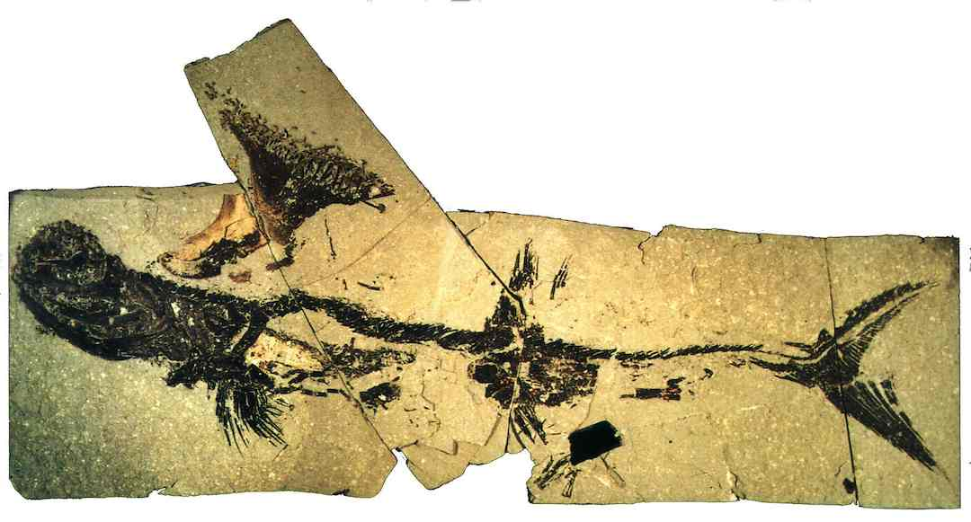

my second example of shark as photographist, also with a local slant: it’s the Bearsden shark. This is a piece of rock from 330 million years ago, containing a fossil of an Akmonistion, an early sea creature. A proto-shark. Here’s what it would have looked like pre-fossilisation:

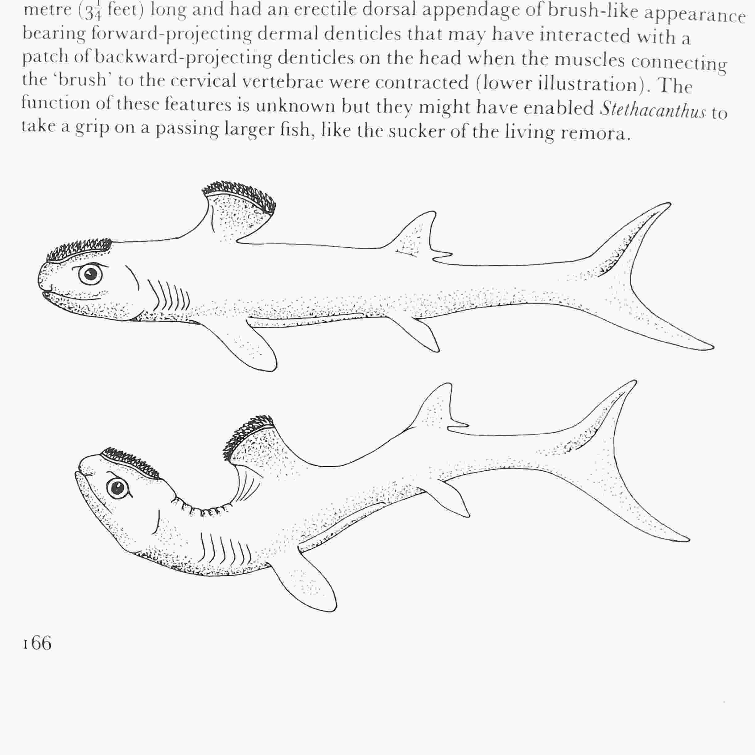

But now: it’s like this. You can see its structure and even the food in its stomach.
This was dug up from Lower Carboniferous shale (apparently) in 1982 in Bearsden, over near Clydebank, and it’s now in the Hunterian museum, in Glasgow.

I’d like to make the case here for including this bit of rock – the shark, the bones, the stone – in the category of photography, considered in the broadest of terms.
I’m showing you a photo of a fossil. But the fossil itself is not a photograph, of course. Or is it? Think about the process of its creation and see if it sounds similar to the analogue photography process I just described.
Take your sea creature, your Akmonistion. Put it into the right consistency and chemical make-up of mud in an enclosed space. Cover it, so the shark can’t emerge or develop legs or anything. Keep it in the dark and under pressure, for millions of years so that a fossil develops. Wait. Look.

I’m a bit hazy on fossils, but the general process for them is: the organic matter decays. The inorganic, that is, minerals such as calcium in the bone or cartilage structure, these stay in place. Water makes its way in, and the minerals in the water precipitate, filling the skeletal space with new, reinforced stone. Surrounded by other, mud-based stone.

So anyway it’s science but you end up, as a result of confinement within a dark, occluded space, with specific chemical changes happening there, over a particular extent of time; you end up with a visible record of what is no longer there.

That’s my second example, of something that is not properly a photograph, but I’m arguing for expanding the category, to say, well, maybe it is, a type of shark photo, following the logic of the process, and what we end up with here: a picture on the wall.

And finally (for now) I’ll steer into the eye of the shark.
You know how the eyeball works, in humans, sharks:
light comes in at the front, is focussed by the lens, and lands on the retina at the back. The cells in the retina are stimulated by light; they pass the info about this chemical shift along the optic nerve up to the brain.

here’s a diagram, from circa 1492, by Leonardo da Vinci.
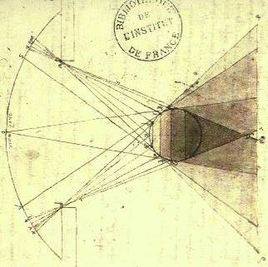
This is actually an investigation into shadow round a sphere, but his notebooks are so beautifully drawn, and it reminds us of the eyeball. This is like that. Imagine that the light’s coming in from the right on this picture, and is directed onto the curved screen of the retina over on the left.

In my first book I was interest to learn about the differently shaped cells of the retina; you have rods and cones in the eye, and I was looking into whether the great white shark sees in colour or not, and what this tells you about its film-watching preferences.

But for my new book, I looked more at the idea of the mirror, as used in the eye of the shark. There’s an excellent scientific paper from 1967, by icthyologist Karl Kuchnow, about shark vision.
Which explains that, here at the back of the lemon shark’s eye, just behind the retina, there is a whole array of tiny platelets. Like this, if you zoom in to a cross section of the eye.

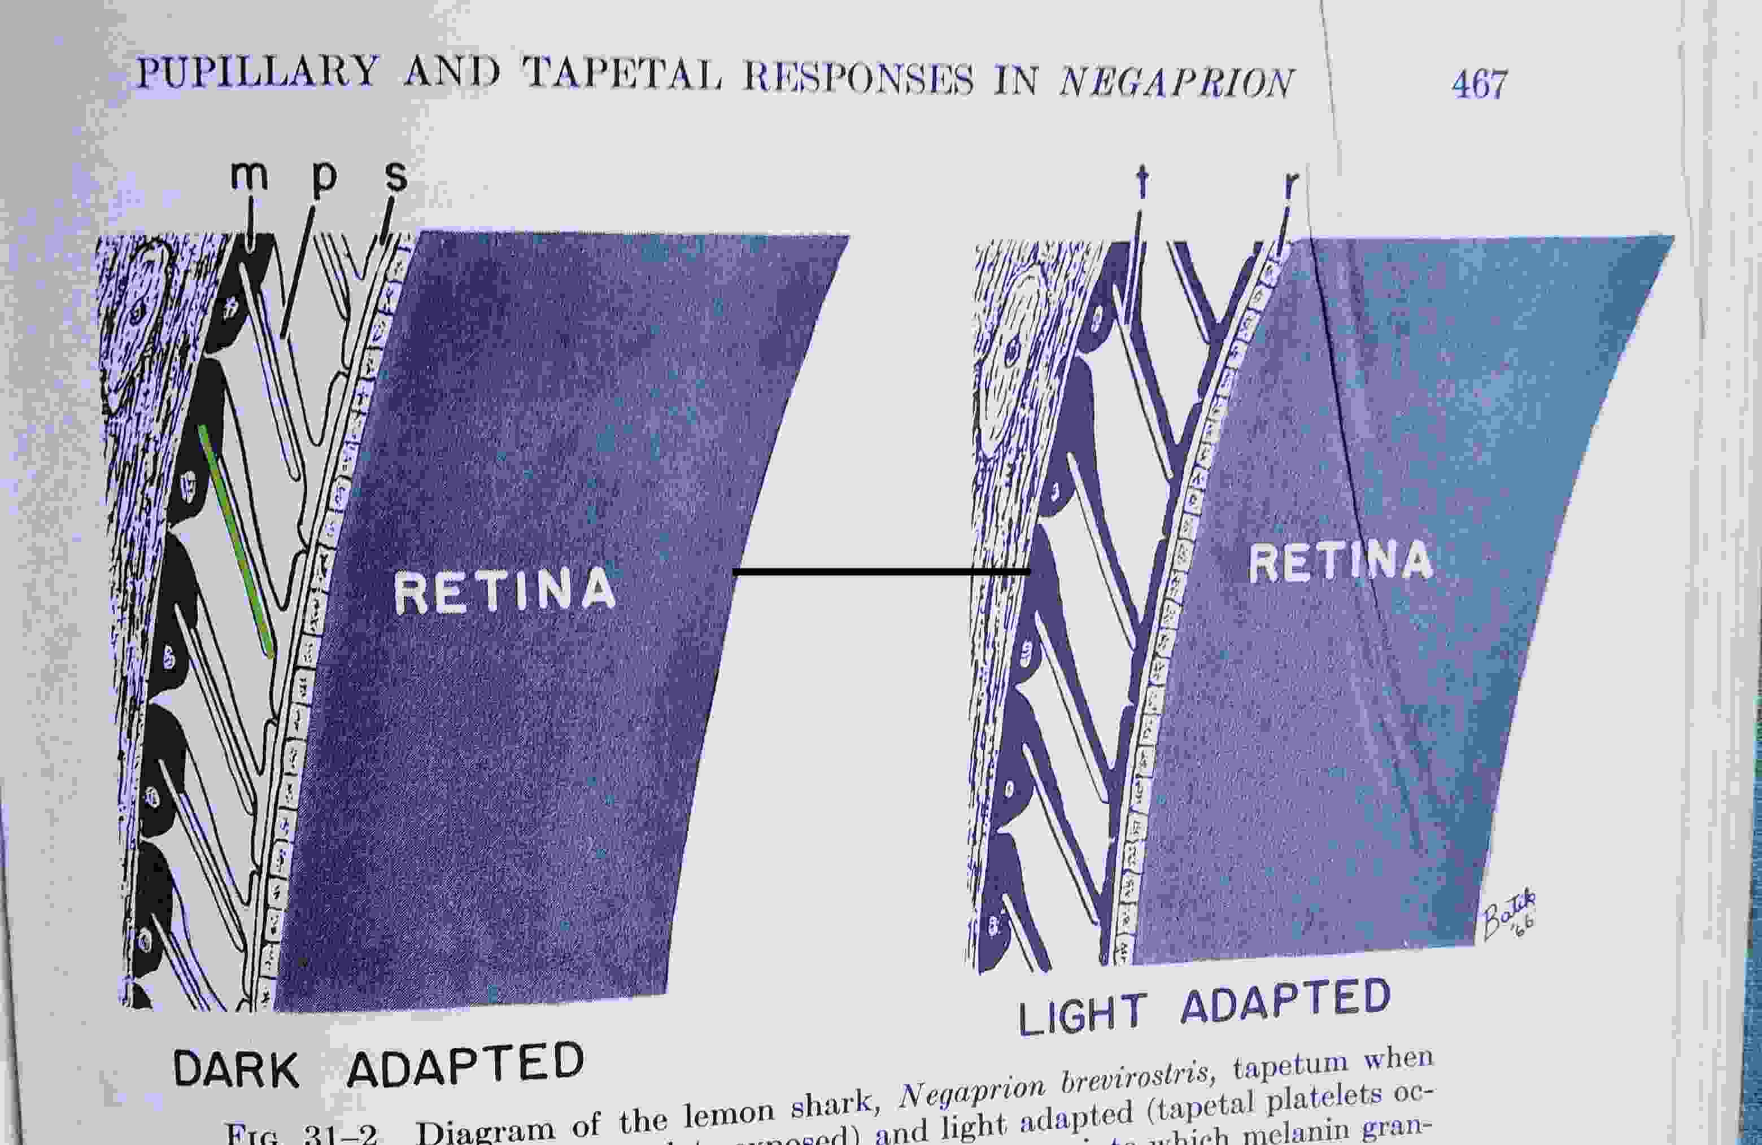

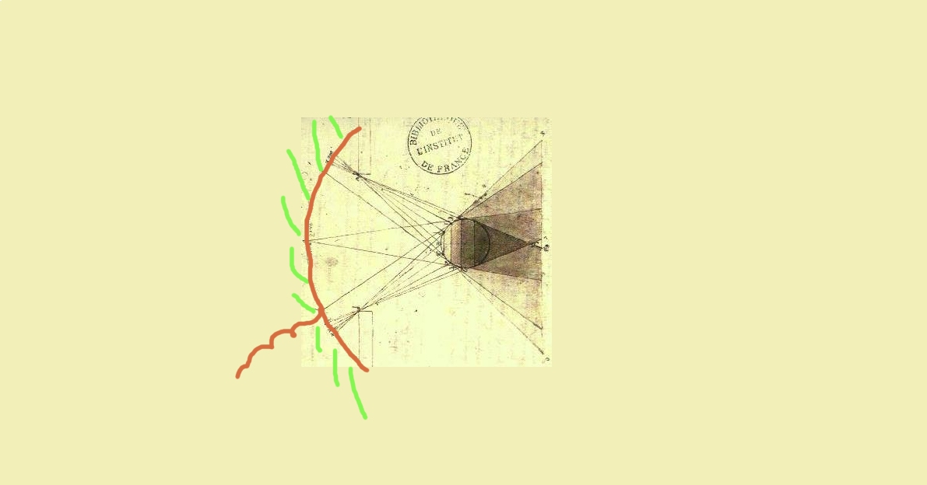
Here’s the scientist Kuchnow’s diagram of the shark’s retina, but it’s a bit complex, so I’ve drawn my own simplified version.

Here all round the back behind the retina there are these platelets, angled to catch the light as it comes. They are made of guanine, a shiny, reflective substance, and they work just like a silvered mirror; they bounce back the light through the retina so that it can be registered and processed a second time. Light and the image comes in once, is sent down the optic nerve to the brain. Then thanks to these mirrors the same light and image is reflected back and used a second time, moments later. The shark has twice the photo-information, that it can use in order to build up its picture of the world.

This is cool. But look, too, at this second version of the image:
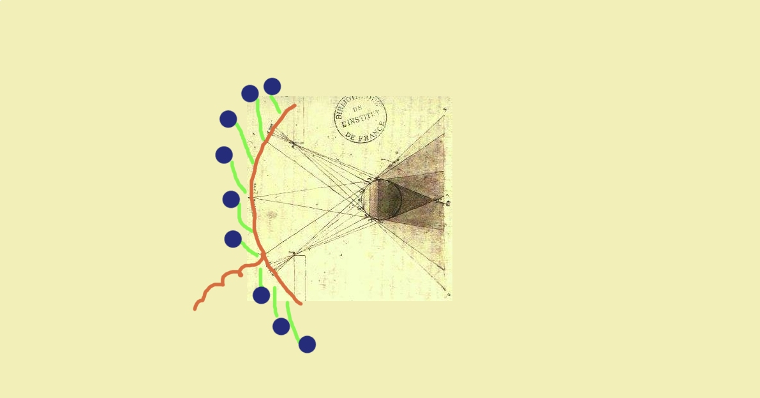

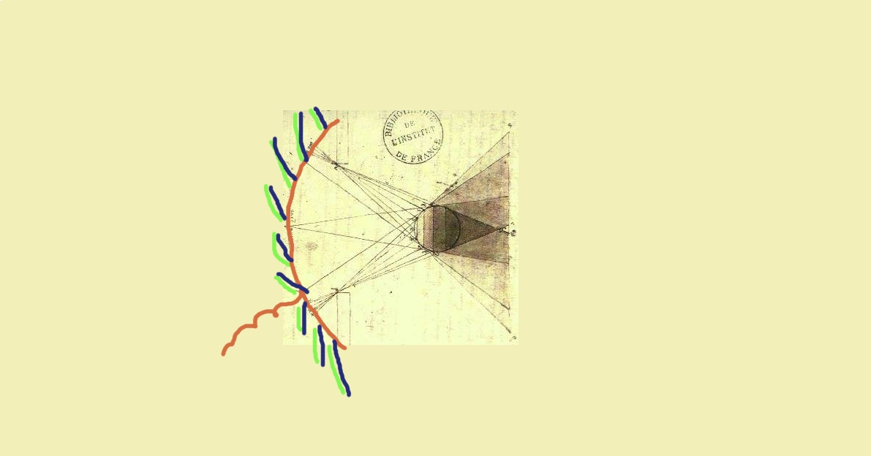
in addition, next to each silver platelet there is a reservoir of melanin, an inky black substance. Here, a blue dot. Normally, in the dark of the underwater, the shark uses the shiny guanine plates to enhance its vision. But there are some circumstances where it’s bright enough, and the shark doesn’t need a double dose. In this case, it opens up the melanin reservoirs, to flood black liquid - like this –

over the silver platelets. Now, the light, passes throught the retina the first time, but instead of being reflected for a second use, it’s just absorbed by the blacked-out platelets. The mirrors don’t work any more; the image isn’t reused; the shark consumes it only once.

I love this case: it’s like inking over a mirror, or using the censor’s black pen to cross out text. A way to negate or prevent the dissemination of information. A sort of secrecy, in the relationship between the black and the silver of the image.

And the reason I propose this as my last of three examples of shark as photo-graphist, is that it’s a clear reminder of the structure of the late twentieth century single lens reflex camera, the box with the lens and the mirror inside, containing the camera film, which is a gelatin strip or spiral coated in silver halide crystals, that react to the light as it comes in.
A hundred and fifty years later than the basic process I described above, analogue camera film still works in the same way. Now instead of ferrous salts brushed over writing paper, it’s silver halides suspended over plastic, but the idea is the same: the silver reacts to the light that’s been admitted, to a certain extent, when you click the shutter. Then, during the developing process, further chemicals either fix the altered silver in place, or it’s washed away, untransformed. To make the image, the camera film’s silver is washed off, into the tray of developer liquid, rinsed in water, poured away down out the drain.

In our film camera photographs, chemicals that could have been parts of the image are washed off, they flow away, into the sea eventually. The ocean is full of lines, but it’s also full of unfinished images, full of potential parts of the picture. They’re all there, that’s what we swim or surf through, what we drink even – the unseen parts of the photographs. They are in our surroundings; they’re what we flow through; they’re our medium.

That’s my third suggestion. To recap, my three shark photo-graphist proposals are:
One: photography isn’t just one thing;
two: more things are photography than you might think;
and three: photography and images flow around us everywhere, inescapably.

To back up this last point, or all of them, I’ll offer some more:
when I’m in the right frame of mind, I find that everything is photos of sharks.
Here’s a selection, mainly from right here round Edinburgh. Some people see visions of the Virgin Mary; I’m just wired this way.

I see sharks when:
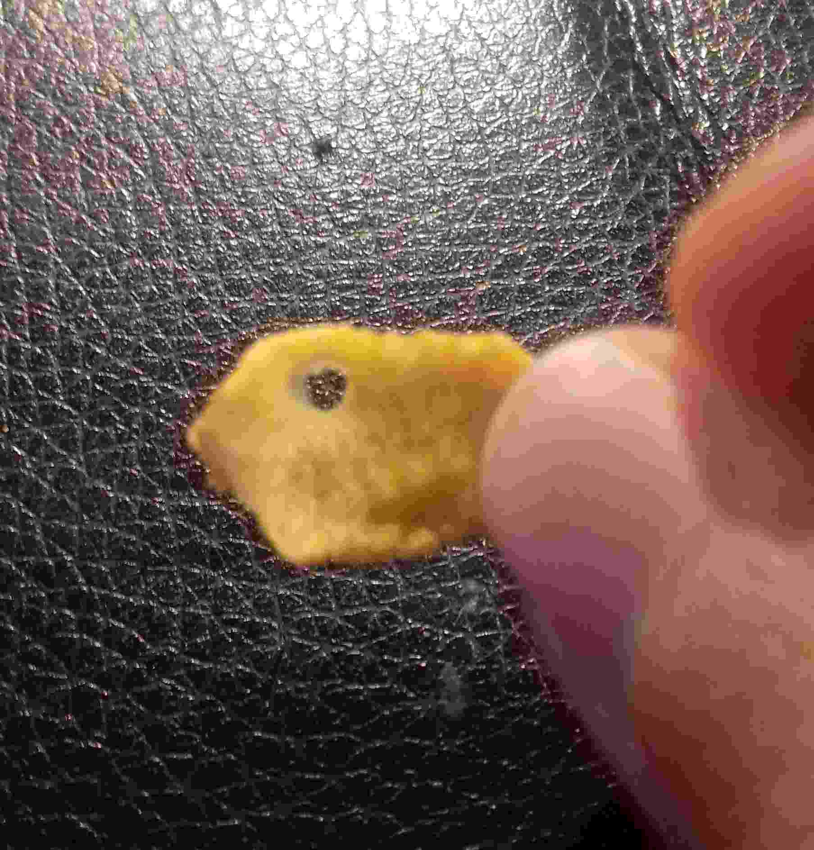
I’m eating cornflakes

or

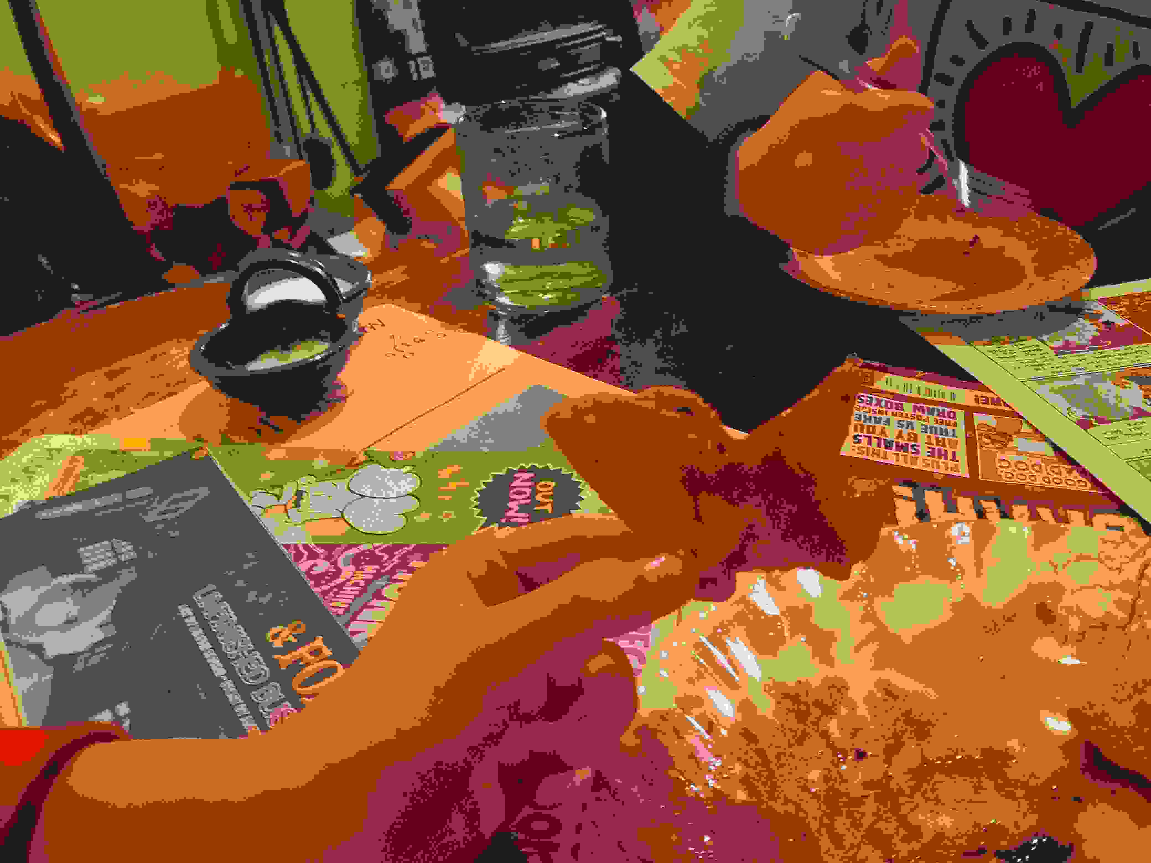
when Ingrid’s making gyozas;

or

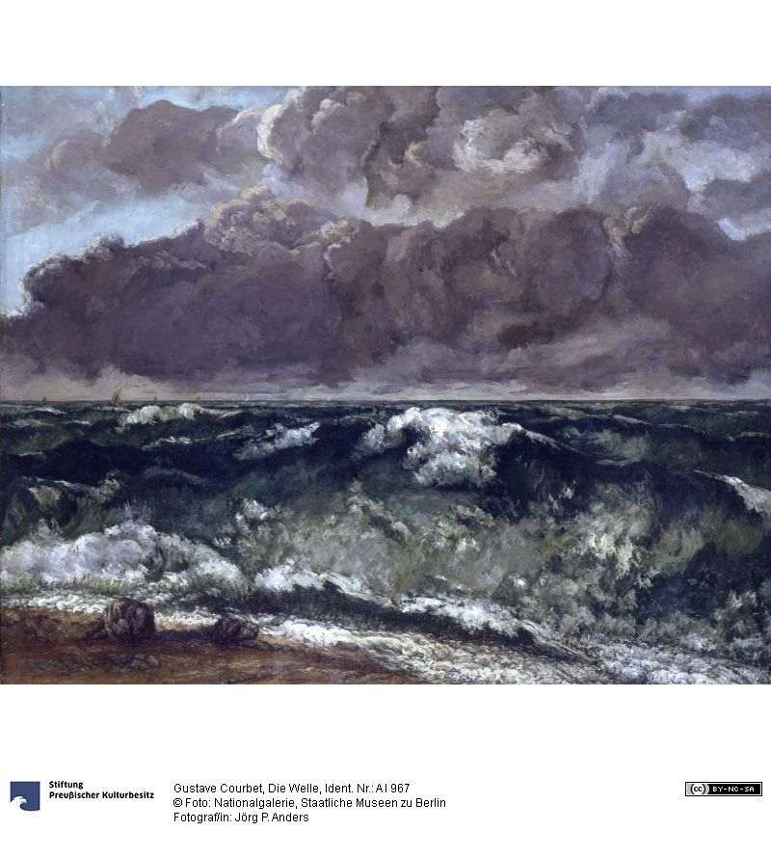
in French impressionist paintings of waves;

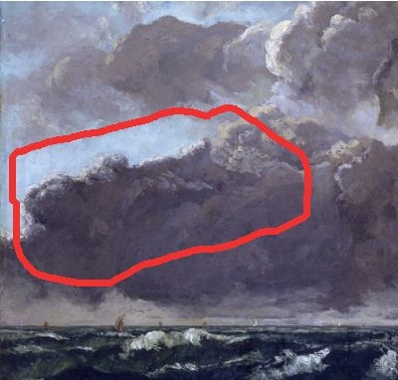
here, it’s all in the details.

Or when I’m walking down the street:
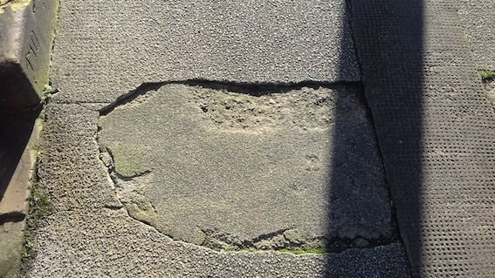

here’s a Greenland shark in the pavement; they are notoriously lazy. It’s on Comely Bank Ave.

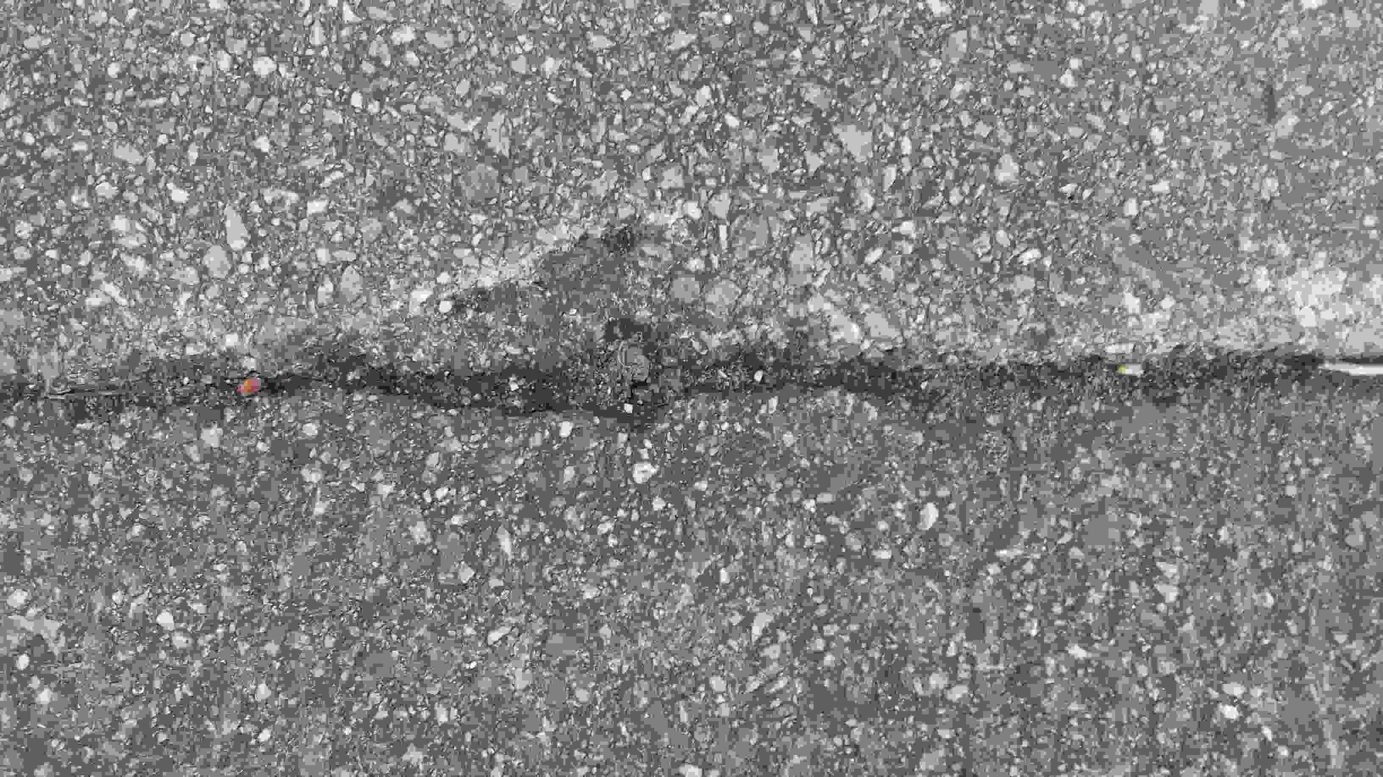
here’s another one, more streamlined, in a crack .

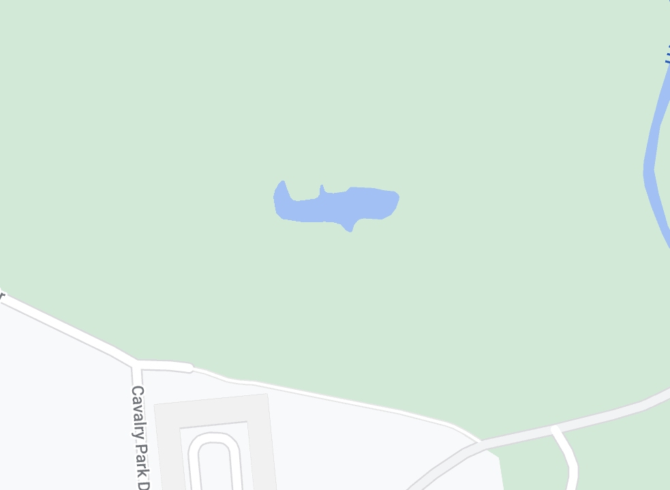
I see sharks when I’m getting the bus to Cavalry Park.

you get the picture.

So, with all of this, what I want to leave you with is the idea that photography isn’t really about making a picture nor an object. It is, instead, about developing and nurturing a way of seeing, it is about finding and making doubleness and repetition in the world. And it does this through making more than one picture or view, through using metaphor in order to find echoes and duplicates, in order to show or to say, these things are similar.

Photography lets you see something once with your own eyes then (like the shark’s mirrors) it lets you double it. It doubles the world through time as you see it once with your normal eyes, then again when you see how it looks in the print. Or, it lets you see the world as someone else shows it to you, when they generously share their vision. You’ve got your own eyes, and you can share in someone else’s.

All this doubleness, the finding of shadows, images, and repetition, makes the world richer, deeper, and more interesting. As I said, I wouldn’t talk of the shark as photographer, exactly. But I would describe the shark, very much so, as photo-adjacent; it’s in the region of, nearby, always around.
As I see it, sharks are involved in the creation of, caught up in, lurking by, the photos, all the time. And so, of course, are we. In this sense they’re our double: we are them, they are us.

That’s about it. That’s how I came to write this book. Thank you for listening.

