Roving Report: Paint It Black
16th oct 2022

Hello everyone.
Over the months in my reports I’ve discussed a few photographers: Anna Atkins, Roger Fenton, Brassai, Robert Capa, Andrew Marvell. Tonight I’ll bring in the Harvard academic Peter Galison. He’s… not exactly a photographer, but nearby. In the nimbus of photography.
He has a PhD in physics, and collaborates on art projects, but he’s mainly a historian of science, looking at twentieth century physics and earlier, at how ideas and habits get contagious. He’s into black holes, and was a core part of the team working on the massive, dispersed Event Horizon Telescope, which in April 2019 provided this:

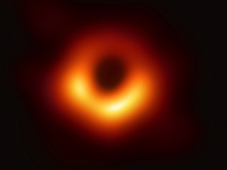
It’s one of the first photographic images of a black hole, of ‘supermassive black hole M87 [or, more precisely, it’s] M87’s silhouette against the hot, glowing matter being pulled in by its powerful gravity’ (explains the New Scientist).
It’s a photo of something – a black hole – that does not allow for light, and it prompts Galison to cite Wittgenstein on games and categories, asking, ‘what counts as a scientific image? What counts as a picture? The notion of a photograph changes…’ he says.

He’s not wrong. This evening, though, I’m interested in another article that Galison wrote (in 2012 for the British Journal for the History of Science), called ‘Blacked-out spaces: Freud, censorship and the re-territorialization of the mind.’
In it, Galison acknowledges that Freud used a great many similies and analogies in explaining his psychoanalytic ideas. Freud compares, for example, the vector of unconscious to conscious thought to the process of examining a set of photographic negatives, and only those which are good enough to be let through this sifting process are printed as actual photographs.
Then Galison suggests a stronger comparison that is present in Freud’s work, the comparison between the censor and the unconscious. There are parallels, says Galison, between the real censorship that was inflicted on letters, newspapers and print publications going to and from Vienna in the late nineteenth century, between this and internal, psychological censorship. A parallel between concrete text destruction and diversion, on the one hand, and internal cover-ups.
With this first, concrete aspect, Galison explains that Freud was dependent on free-moving postal systems, both to carry out his work, discussing ideas with colleagues internationally; and for keeping in touch with his sons, away at war. The free movement of words and ideas, or the impediment to this, affected how he could function, every day.

But of course there’s an abstract parallel to this in Freud’s ongoing ideas about psychic censorship, how the mind blacks out, covers over, disallows memories, thoughts, and understandings that might cause disruption or harm.
Something is forbidden from coming across the border, because it will be too difficult to deal with at the destination. Where it would be, on the front page of a newspaper, for example, there is perhaps a plain white demilitarized zone of missing text. Or there’s a splotch of black ink: Galison says that censors on the Russian border would cover over troublesome or disrespectful text with black, and this became known as ‘caviar’ – a big smear of black over the page / plate.

Here’s a picture (from Galison’s paper) of this Malevichian blacking out.
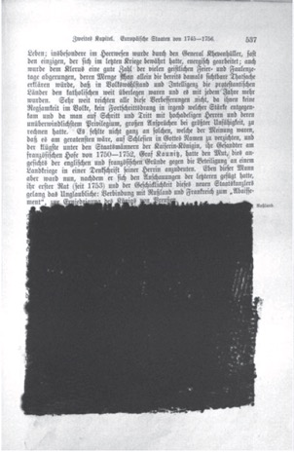

Galison points out that this repression doesn’t happen secretly, but draws attention to itself: when you, the reader, get a paper with gaping absences in the text, you know there is something good there that you’re missing. Same with the unconscious-preconscious-conscious progression: there are huge signs that appear, drawing attention to the very fact that something is covered over here.

Moving unimpeded from Freud’s Vienna to my city and time zone, I can report that from my desk as I’ve been writing this piece, I could hear two workmen, they’re brothers, stripping, cleaning and repainting the smart metal railings of the next house up. They run a concentrated business, doing one task only, but it means that they’ve got good at it. Their outift is called, with commendable directness and with musical good taste, Paint it Black. Which is my theme for this evening.

Like Galison and the painters, I too am keen on the materiality of things going black. Not with caviar, for me, sadly, but with sharks.
Recently I’ve been much taken by a biology paper from 1967, by Kuchnow and Gilbert. It’s called, ‘Pupillary and Tapetal Pigment Responses in the Lemon Shark, Negaprion Brevirostris.’ It’s from a conference on sharks, skates and rays (the elasmobranches), held the previous year, its collected papers.

What happens in this paper is that Kuchnow (he’s the main author) sees that sharks have that reflective eye thing that cats also do; their eyes gleam in the dark. The cause of this is something called the tapetum lucidum (or bright tapestry – shark science is beautifully poetic), which is a layer of tiny platelets on the back of the eyeball, behind the retina. The sequence is: light – lens – retina – tapetum – optic nerve. So making up this tapetum there are thousands of these platelets, all angled – like an array of solar panels in a field – so that they will catch all the light coming in through the retina and reflect it back, so that the retina can use the same light twice, once coming in, once with the photons bouncing back. It’s an energy efficiency measure by the shark, to increase the information reaching its brain by using all the available light two times.
You can see that this part of the shark’s eye is functioning like a mirror. It is ‘rendered silver by crystals of guanine’, explains the experimenter; this is what the light bounces off, the silver guanine. But efficient as this process is, sometimes it is not necessary. If the shark is in a bright environment, it doesn’t need this double dose of daylight. And in this case, something even more interesting happens.

Next to each of these platelets which function as a silvery mirror, there is a little reservoir of black melanin, a pigment. If the surroundings of the shark are well-lit, and there is enough daylight reaching its eye, the shark decides that it does not need to make use of the reflecting platelets – the tapetum – , and it undoes the flood-gates, releases melanin over every shiny surface. Like painting over the mirror. Now the light coming in through the shark’s eye comes in once, is taken from the retina to the brain, processed as an image, acted upon. And once it’s through the retina, it’s just absorbed by this now-layer of melanin. That’s it; there’s no need for the shark to reflect out the rays and use them again, enhancing and nearly doubling the image.

That’s what the shark’s eye does. What the biologist Kuchnow wanted to find out was, how and when does this happen, at what stage of ambient light, and of shark perception, does this process occur, of the reservoirs flooding the mirrors with black ink, how fast does it all happen. And to find out, he sets up this circuit, of a shark in a tank in the garden, with black theatrical curtains round the tank, and outside the tank there’s both a regular Kodak camera with a 24-exposures roll of film in it, and a bright flash light pointed right at the shark. When the shark is ready for its close-up, Kuchnow pulls back the curtains, shines the bright light in the shark’s eye, and at the same time takes pictures. The more guanine, the silvery reflective substance, that is in the eye, the more of the spotlight beam will be reflected, bouncing off the eye, back onto the camera film. Conversely, the more melanin that has flooded in, the less reflective the eye will be, and the less light will be reflected back and caught on the film.

Then Kuchnow goes and develops the film, looks on the strips of negatives to see how these silver halide crystals on them have reacted, and he does maths and charts to work out the shark’s autonomous reaction times, and neuron responses. I would like to see actual picture prints, little snaps, developed from this experiment, but I don’t think that they went on to this stage; they stopped with the negatives.

So, that’s what this scientist was looking for, with darkness and mirrors, cameras, sharks.
What happens when you look, instead, into art and literature for silver mirrors and black ink blotting out the surfaces. You might find Perseus, looking in his mirror so as to get a safe line of sight on the gorgon, Medusa, as he tries to kill her.
Or, you might find, in Jaws the book, someone describing how they saw “a large silver-colored object rise out of the water” (it’s a shark; that’s as described by the eye-witness, one Mr. Daguerre).

Jaws the book has a fantastic history of front cover design. There’s an array of alternative versions, but the most enduring and famous is this:

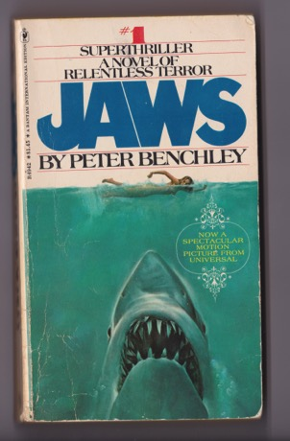
, a shark swimming directly upwards towards a woman swimming, and the word JAWS goes above. It’s a simple idea, which surfaces in lots of iterations.
This first one that’ we’re looking at now is the first US softcover, from Bantam in 1975. It’s of course recognizable because it was also used for the film poster, for Spielberg’s 1975 spectacular motion picture. But the concept was used as the book cover, first.

Swimming backwards a year, here’s the UK paperback, Pan first edition, followed by second edition.
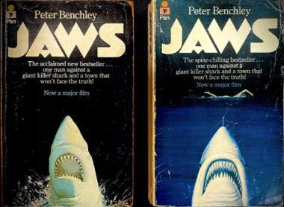
We have here a different, English shark, and it has, un-national-characteristically, better, more aligned teeth than its American counterpart.

And the one on the left here, the first UK paperback edition, is completely different: if you look, you can see it’s jumping in a direction, not swimming straight up. Also, there’s no swimmer.

A nice literary touch on both of these UK editions is the tagline : “one man against a giant killer shark and a town that won’t face the truth”. This is, as Roland Bates suggested in a much earlier session, surely an allusion to Ibsen’s An Enemy of the People (1882), in which the protagonist tries and fails to warn the citizens and politicians of a danger – bacteria-polluted spa waters – to which they are now wilfully exposing their tourist visitors.
Anyway, all of these paperback covers are influenced by the original hardback, from Doubleday, 1974.

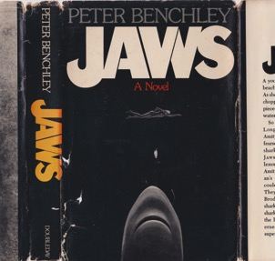

It’s obviously the same idea, but I point out that this shark has no eyes, very few teeth, and it’s not swimming in the blue water but in blackness.
Apologies to people who are intimately familiar with my book Sharks, Death, Surfers, as some of this will be not new to you. But, there is something I only recently stumbled over, that happily lets this whole report qualify as current affairs, economics and markets division. And it’s this:

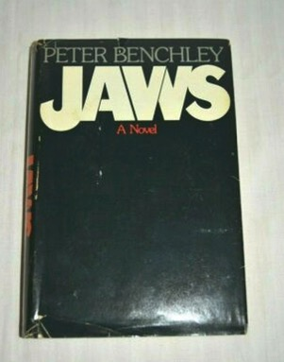

Which is a hardback cover, also from publishers Doubleday, also 1974.
As you can see, – sorry about the gleam, the reflection on the picture – it’s similar in that there’s a black background that says JAWS, but, there’s no swimmer and there is no shark!

It’s for sale on ebay for 14 hundred dollars, by a certain greenport NY, who suggests that it might be a proof copy, and who writes:
“an employee at Doubleday took it home and, shazam, it's now on the open market 43 years later! Be the only kid on the block with this rare book.”

Well, I am not the only kid; I did not buy it. But I like it, its suggestion that everything gradually fades to dark, reverts to the black back of the eye, inking over all the secrets and dangers. Even though there are just a few words left on the page, like with Freud’s caviar censorship, the black marks tell us that something is still there. Just under the surface. That we should look out for. Even if we have to use a mirror, or photographs, or both, or even books, to do so.
That’s it for this evening. Thanks.

